June 2022 Activities
Must have two or more participants for activities to take place
Sunday | Monday | Tuesday | Wednesday | Thursday | Friday | Saturday
 |  |  | 1 | 2 | 3 | 4
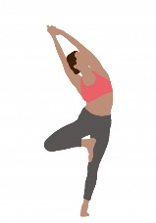 |  |  | Bingo 1:15-3:30 | Cards/Board Games 1:00-4:00 | Rock Painting After Lunch  Billiards 1:00-4:00 | 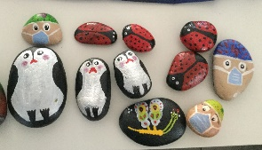
5 | 6 | 7 | 8 | 9 | 10 | 11
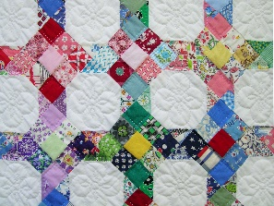 | Yoga 10:30-11:30  Quilting 10:00-4:00 | Knitting 1:00-4:00 | Bingo 1:15-3:30 | Cards/Board Games 1:00-4:00 | Corn Hole After Lunch  Billiards 1:00-4:00 | 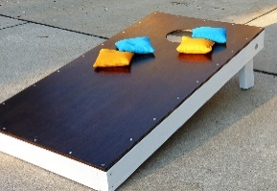
12 | 13 | 14 | 15 | 16 | 17 | 18
 | Yoga 10:30- 11:30  Quilting 10:00-4:00 | Knitting 1:00-4:00 | Bingo 1:15-3:30 | Cards/Board Games 1:00-4:00 | Genealogy for beginners After Lunch  Billiards 1:00-4:00
19 | 20 | 21 | 22 | 23 | 24 | 25
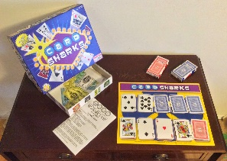 | Yoga 10:30-11:30  Quilting 10:00-4:00 | Knitting 1:00-4:00 | Bingo 1:15-3:30 | Cards/ Board Games 1:00-4:00 | Tech Class  (Spam)  After Lunch  Billiards 1:00-4:00
26 | 27 | 28 | 29 | 30
 | Yoga 10:30-11:30  Quilting 10:00-4:00 | Knitting 1:00-4:00 | Bingo 1:15-3:30 | Cards/ Board Games 1:00-4:00

