May 2022 Activities
Must have two or more participants for activities to take place
Sunday | Monday | Tuesday | Wednesday | Thursday | Friday | Saturday
1 | 2 | 3 | 4 | 5 | 6 | 7
 | 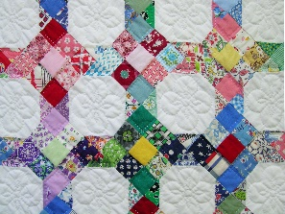 |  |  | 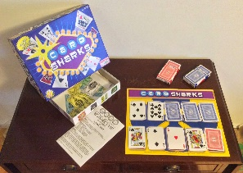 | Organizing Senior Center Photos 1:00-4:00  Billiards 1:00-4:00 | 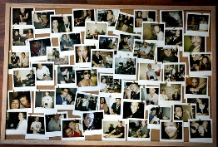
8 | 9 | 10 | 11 | 12 | 13 | 14
 | Yoga 10:30-11:30  Quilting 10:00-4:00 | Book Club 10:00-11:00  Knitting 1:30-4:00 | Native Arts 10:30-11:30  Bingo 1:15-3:30 | Cards/Board Games 1:00-4:00  Pong 1:00-2:00 | Shuffle Board 1:00-4:00  Billiards 1:00-4:00 | 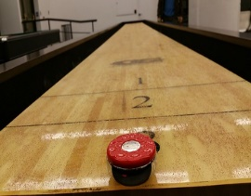
15 | 16 | 17 | 18 | 19 | 20 | 21
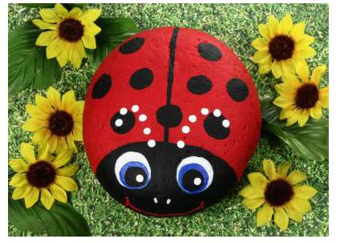 | Yoga 10:30- 11:30  Quilting 10:00-4:00 | Tech Class 10:30-11:30  Knitting 1:30-4:00 | Rock Painting 10:00-11:30  Bingo 1:15-3:30 | Wheel of Fortune 10:30-11:30  Cards/Board Games 1:00-4:00 | Plant Studies 1:00-4:00  Billiards 1:00-4:00
22 | 23 | 24 | 25 | 26 | 27 | 28
 | Yoga 10:30-11:30  Quilting 10:00-4:00  Crafts 1:00-4:00 | Wii Bowling 1:00-4:00  Knitting 1:30-4:00 | Pioneer Day 10:30-11:30  Bingo 1:15-3:30 | Jeopardy 1:00-2:00  Cards/ Board Games 1:00-4:00 | Field Trip to Alaskan Hardy Gardens (leave after lunch)  Min of 5 max 7 people  Cost $7  Must sign up and pre pay
29 | 30 | 31
 | Center Closed for Memorial Day | Corn Hole 10:00-11:00  Knitting 1:30-4:00 | 